MySQL Virtual Access Instructions

The Web Links section is near the bottom of the Task Overview. Click on the “Database Access” link in this section.

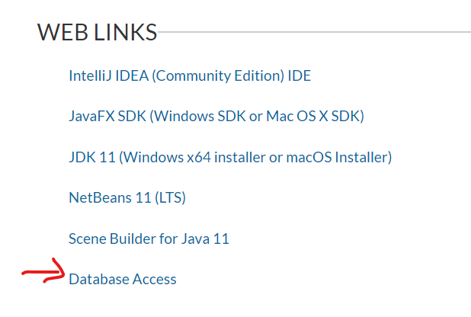

Clicking on “Database Access” will navigate you to this page:

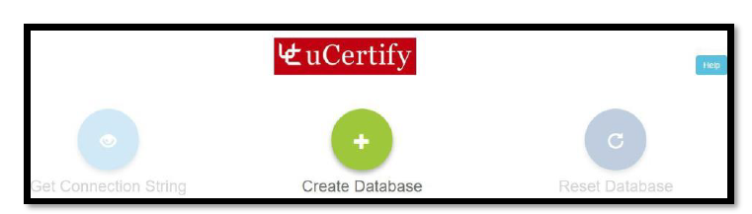

Click “Create Database” to create a new database and generate a connection string:

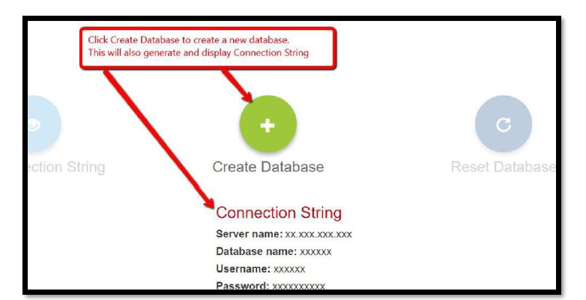

Click “Reset Database” to reset the database if necessary. (If your course version has changed, and the form of the database has changed, this may generate a new database). If the database already exists, you can generate the connection string by clicking “Get Connection String.”

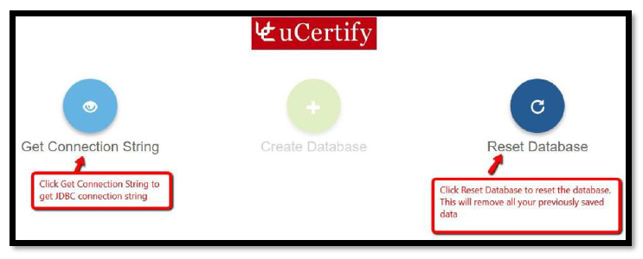

You will be using either Apache NetBeans 11 or IntelliJ IDEA to develop your project.

To include the MySQL connector library within an Apache NetBeans project, you must do the following:

1. Open NetBeans.
2. Open your project.
3. Download the platform-independent JDBC connector file from <https://dev.mysql.com/downloads/connector/j/> and extract the zip file. (This will require creating an Oracle account.) Inside this file is the “mysql-connector” JAR file.

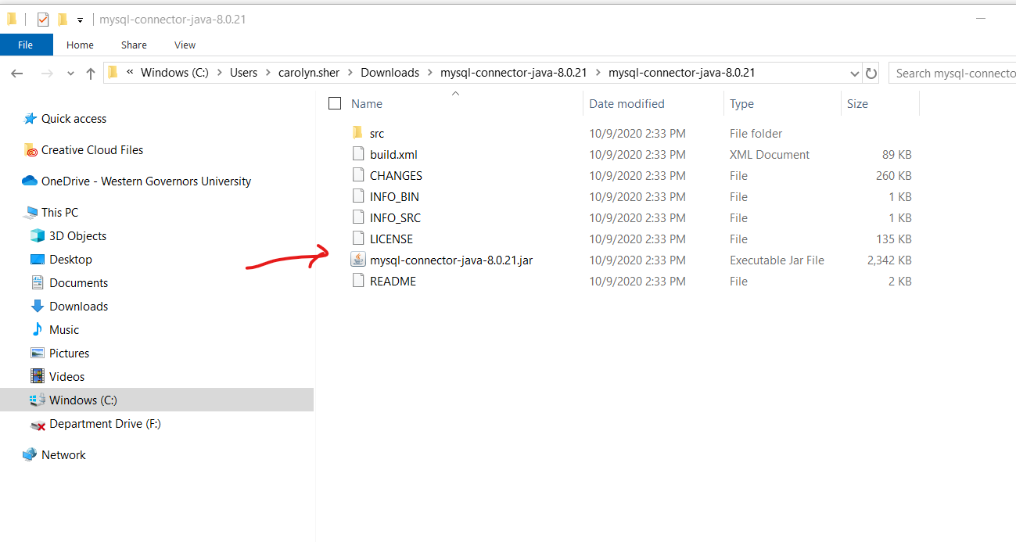

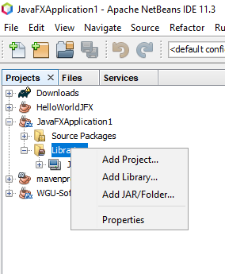

1. Back in NetBeans, select Libraries from the hierarchy and right-click on it.
2. To use the library downloaded from Oracle, click Add JAR/Folder:

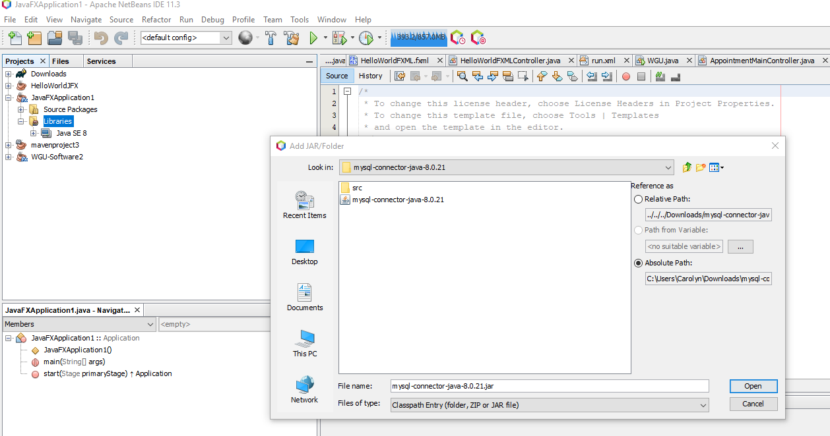

1. Browse your computer to the MySQL JDBC driver, and select it by clicking Open.
2. The MySQL connector should be listed in the Libraries:

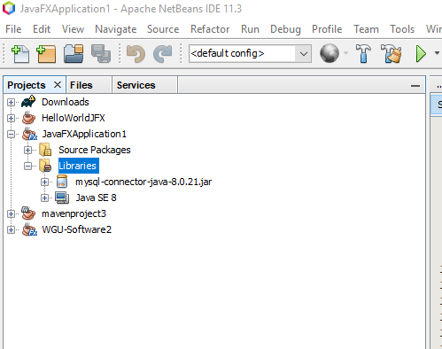

To include the MySQL connector library in an IntelliJ IDEA project, you must do the following:

1. Open your project.
2. Go to the File menu and select Project Structure:

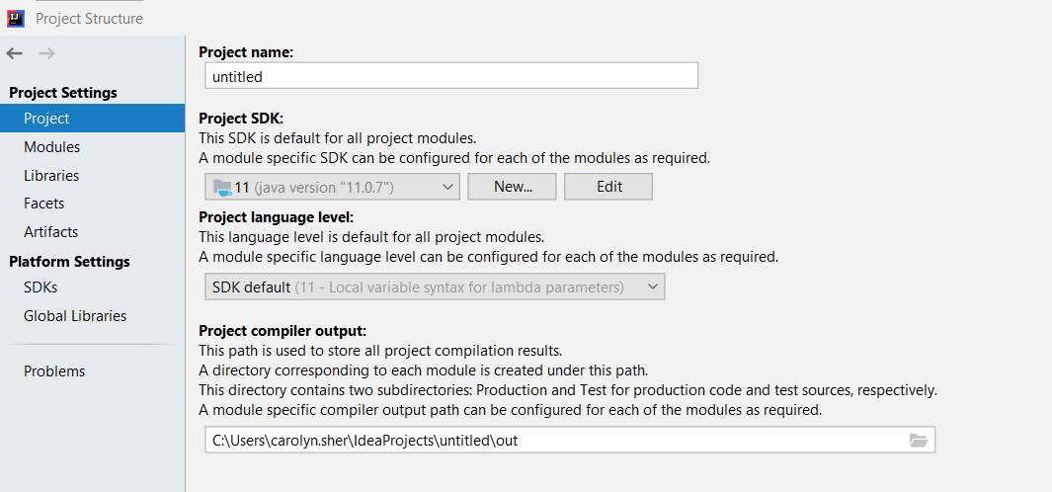

1. Choose the Libraries tab, and click on the plus sign:

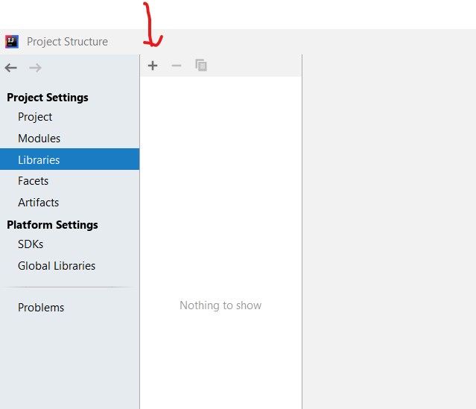

1. Choose Maven if you want to download the library from Maven. Choose Java if you have already downloaded the library from Oracle.

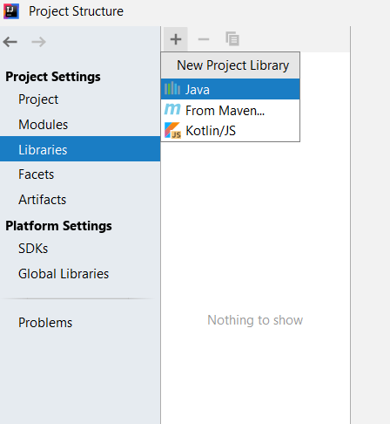

1. Browse to your connector file and choose it:

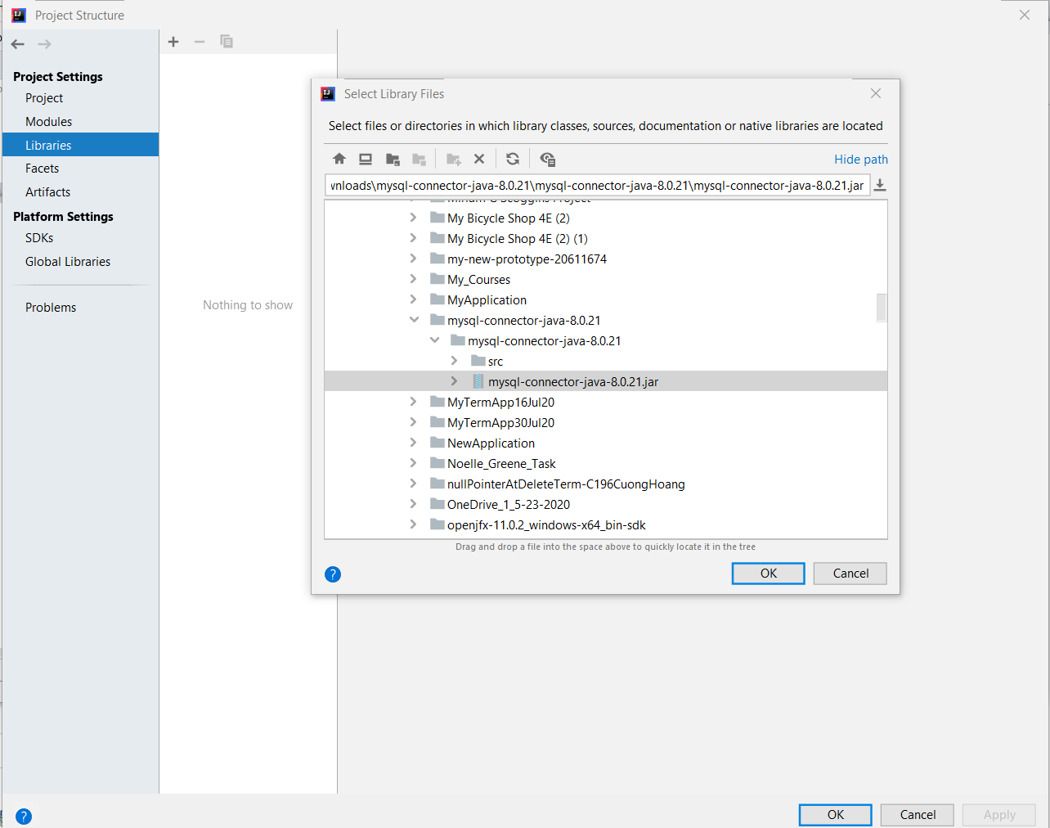

1. Add the library to your project:

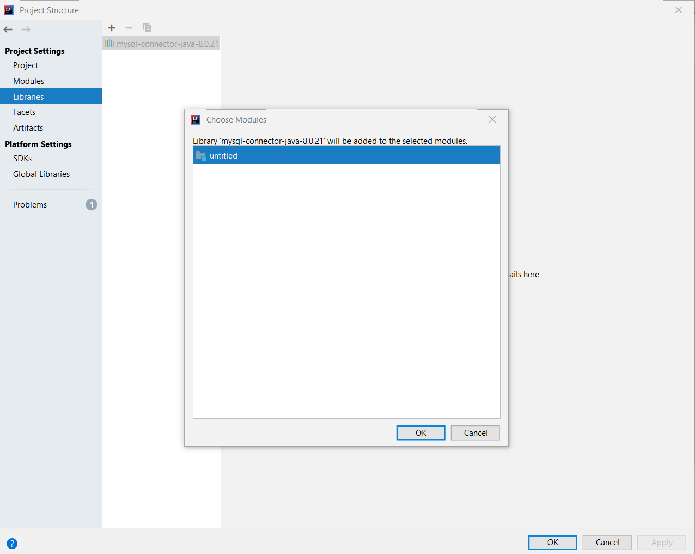

1. Click on Apply and then OK:

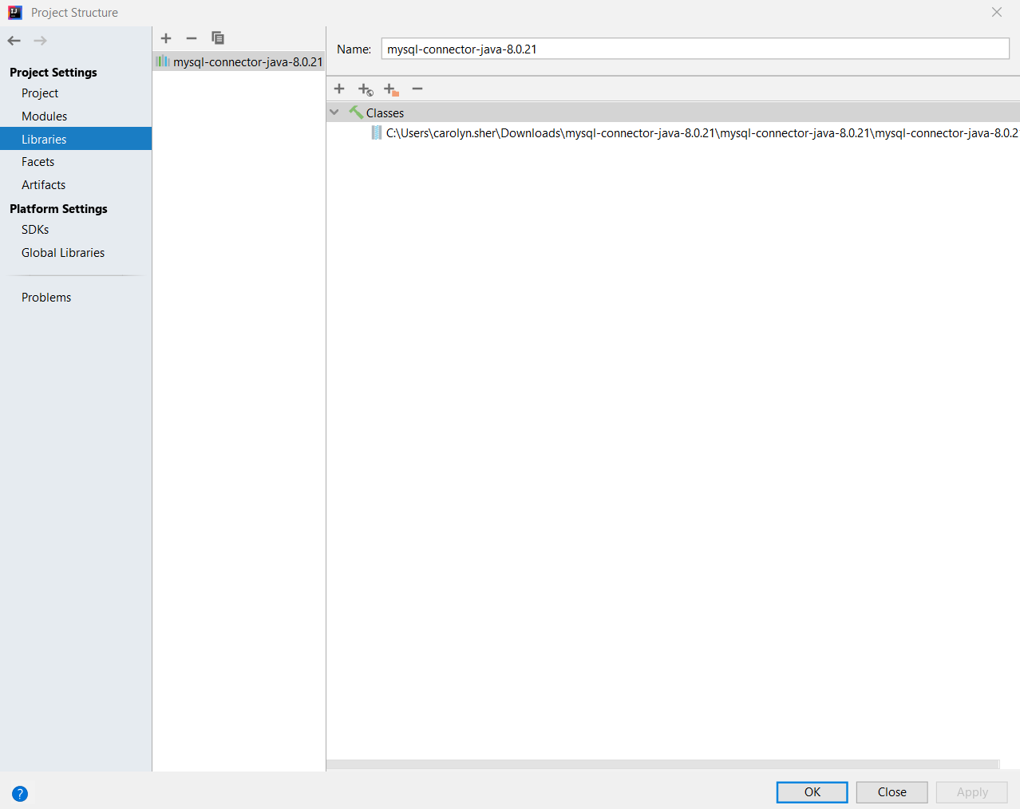

1. The connector file should be listed as an external library:

